

**COVID PRECAUTION SENSOR**

**A MINI PROJECT**

**REPORT**

**SUBMITTED BY:**

CHITRA.S-1NH18EE010

E.KAVIPRIYA-1NH18EE013

GREESHMA CHENNAREDDY-1NH18EE017

***In partial fulfilment for the award of the degree of***

**BACHELOR OF ENGINEERING**

**IN**

**ELECTRICAL AND ELECTRONICS ENGINEERING**



**BONAFIDE CERTIFICATE**

This is to bonafide that the mini project report entitled “COVID PRECAUTION SENSOR” submitted by CHITRA.S(1NH18EE010),E.KAVIPRIYA(1NH18EE013) and GREESHMA CHENNAREDDY(1NH18EE017) Department of Electrical Engineering, New Horizon College of Engineering, Bangalore in partial fulfilment for the award of the degree of bachelor of engineering, is a record of bonafide work carried out by him/her under my supervision, as per the NHCE code of academic and research ethics.

The contents of this report have not been submitted and will not be submitted either in part or in full, for the award of any other degree or diploma in this institute or any other institute or university. The project report fulfils the requirements and regulations of the institution and in my opinion meets the necessary standards for submission.

Mr. Joshua Daniel Raj Dr. Mahesh.M

Project Guide HoD



**ACKNOWLEDGEMENT**

With immense pleasure and deep sense of gratitude, We wish to express our sincere thanks to our supervisor Mr. Joshua Daniel Raj, Senior Assistant professor, Department of Electrical Engineering, New Horizon College of Engineering, without his motivation and continuous encouragement, this mini project would not have been successfully completed.

We are grateful to the chairman of New Horizon Educational institution, Dr. Mohan Manghnani for motivating us to carry out research in NHCE and for providing us with infrastructural facilities and many other resources needed for our project work.

We express our sincere thanks to Dr.Mahesh.M, HOD, Department of Electrical Engineering, New Horizon College of Engineering for his kind words of support and encouragement.

We wish to extend our profound sense of gratitude to our parents for all the sacrifices they made during our project and providing us with moral support and encouragement whenever required.

Date:

Place:Bangalore

Chitra. S

E. Kavipriya

Greeshma Chennareddy

**ABSTRACT**

The World Health Organization(WHO) has declared the novel coronavirus 2019(Covid-19) an international health emergency due to severity of infection progression. The pandemic is becoming more serious due to its continuous spread globally and unavailability of appropriate therapy and diagnostics systems.



Fig.1.1

Using face masks, sanitizers have shown positive results to the disease spread reduction. But, in the absence of an approved vaccine safety precautions has to be taken. As a part of protecting ourselves from the increasing threat of the spread of Covid-19, social distancing has become a norm in any public event and gathering.

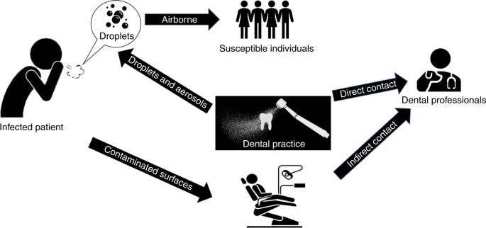

Fig.1.2

With the aim of proposing the scope and extent of the impact, our project aims to help reduce the spread of the disease by using an ultrasonic sensor which measures the distance between itself and the object in front of it, whether an object or a person and warns the person thus ensuring social distancing.

**TABLE OF CONTENTS**

1. **ABSTRACT**
2. **INTRODUCTION**
3. **CIRCUIT DIAGRAM**
4. **HARDWARE REQUIREMENTS**
5. **CIRCUIT DIAGRAM AND WORKING**
6. **RESULTS**
7. **CONCLUSION**
8. **BIBLIOGRAPHY**
9. **APPENDICES**

**INTRODUCTION**

The Corona virus Disease 2019(COVID-19), first recognised in December 2019 in Wuhan, China, is the latest respiratory disease pandemic currently plaguing global health. The disease spread globally in just a few weeks. The common symptoms of this disease include fever, soar throat, nasal congestion, tiredness, loss of taste and smell. It is transmitted directly from person to person through respiratory droplets and indirectly via surfaces. The disease is also spread through asymptomatic people.



Fig.2.1

As the spread of the disease is rapid, many protection and safety measures were taken by the government to reduce the spread of the virus, such as usage of face masks and sanitizers, social distancing, self-isolation, quarantine, cancellation of public gathering and movement within country borders and abroad. Most of the safety regulations are still applied due to unstable condition. This pandemic has a caused a huge change in our everyday routine and activities.



Fig.2.2

Although certain measures taken by the government have shown positive results in the disease spread reduction, the crucial problem is the lack of approved vaccine and medication. Therefore, our project aims to help the public follow one of the COVID-19 safety rules which is social distancing. This device warns the person when social distancing is not followed. Overall, we as individuals need to adapt social distancing in order to safeguard ourselves and that is what the device promotes through its visual and audio aids via the buzzer and LED.



Fig.2.3

Therefore, the main objective of our project is to ensure social distancing and protect ourselves from the disease.

**BLOCK DIAGRAM**

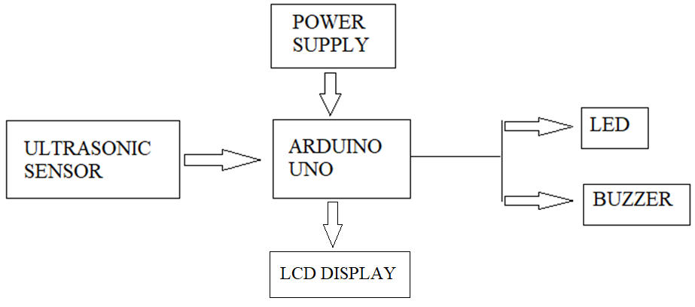

Fig.3. Block Diagram

The Ultrasonic sensor measures the distance between itself and the object in front of it, whether an object or a person. If something comes up within 100cm of the sensor, the buzzer sounds, the red LED is turned on and the distance measured is displayed on the LCD along with a message SAFE DISTANCE, within the range of social distancing. If the distance measured by the ultrasonic sensor is greater than 100cm the red LED is turned on and the distance measured is displayed on the LCD with a message TAKE PRECAUTION.

**LIST OF COMPONENTS**

|  |  |  |
| --- | --- | --- |
| SL.NO | COMPONENTS | VALUE |
| 1. | ULTRASONIC SENSOR |  |
| 2. | POTENTIOMETER | 100K |
| 3. | ARDUINO UNO |  |
| 4. | LCD | 16X2 |
| 5. | BUZZER |  |
| 6. | RESISTORS(2) | 1K |
| 7. | LED (LIGHT EMITTING DIODE)(2) | RED,GREEN |

**HARDWARE REQUIREMENTS**

The circuit diagram of Covid Precaution Sensor consists of an ultrasonic sensor which measures the distance between itself and the obstacle and sends the signal to the arduino.If social distancing is ensured the Green LED will glow otherwise the red LED will glow and buzzer is turned on.

**SPECIFICATION OF COMPONENTS:**

**RESISTOR**

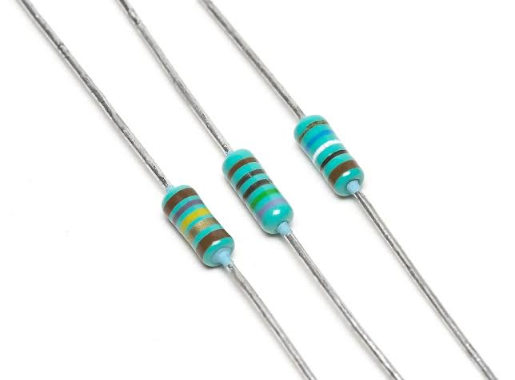

Fig.4. Resistors

A resistor offers a resistance to the flow of current and act as voltage droppers or voltage dividers. They are “Passive Devices”, that is they contain no source of power or amplification but only attenuates or reduces the voltage signal passing through them. For high current operations resistance of higher current ratings are used. Resistance is nothing but the hindrance that a substance offers to the flow of electric current and it is represented by ‘R’. The standard unit of resistance is ohm. When an electric current of one ampere flows through a component across which a potential difference of 1V exists, then the resistance of that component is one ohm.

In general, When the applied voltage is held constant, the current in a direct-current (DC) electrical circuit is inversely proportional to the resistance. If the resistance is doubled, the current is cut in half; If the resistance is halved, the current is doubled. This rule also holds true for most low-frequency alternating AC systems, such as household utility circuits. In some AC circuits, especially at high frequencies, the situation is more complex, because some components in these systems can store and release energy, as well as dissipating and converting it.

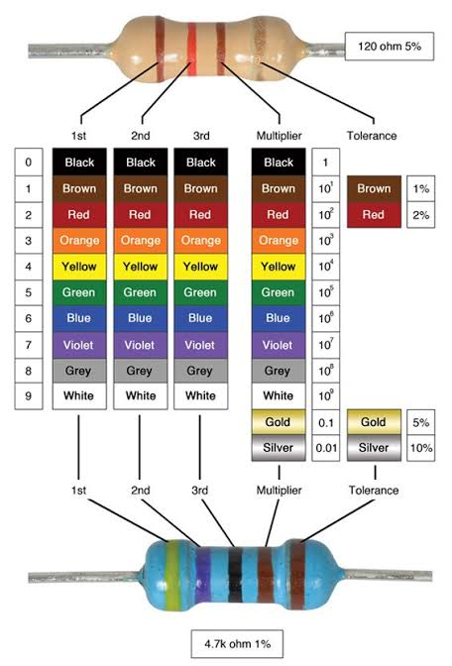

Fig. 4.1. Colour code of resistors

**PIR SENSOR**

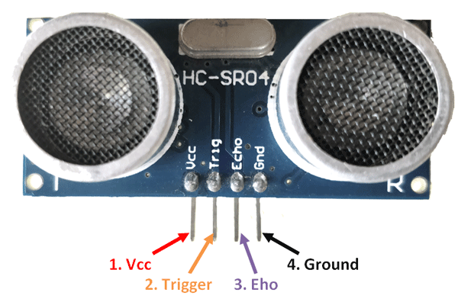

Fig. 5.HC-SR04 Ultrasonic sensor

An ultrasonic sensor is an electronic device that measures the distance of a target object by emitting ultrasonic sound waves, and converts the reflected sound into an electrical signal. As shown above the **HC-SR04 Ultrasonic (US) sensor** is a 4 pin module, whose pin names are Vcc, Trigger, Echo and Ground respectively. The Vcc pin powers the sensor, typically with +5V. Trigger pin is an Input pin. This pin has to be kept high for 10us to initialize measurement by sending US wave. Echo pin is an Output pin. This pin goes high for a period of time which will be equal to the time taken for the Ultrasonic wave to return back to the sensor. This pin is connected to the Ground of the system.

This sensor is a very popular sensor used in many applications where measuring distance or sensing objects are required. The module has two eyes like projects in the front which forms the Ultrasonic transmitter and Receiver. The sensor works with the simple high school formula that

**Distance = Speed × Time**

The Ultrasonic transmitter transmits an ultrasonic wave, this wave travels in air and when it gets objected by any material it gets reflected back toward the sensor this reflected wave is observed by the Ultrasonic receiver module as shown in the picture below

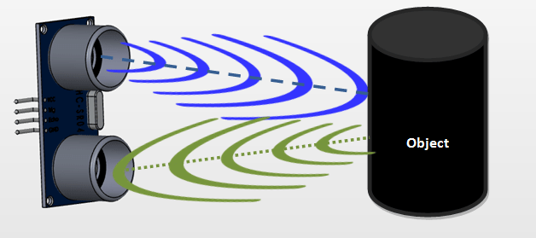

Fig.5.1

Now, to calculate the distance using the above formulae, we should know the Speed and time. Since we are using the Ultrasonic wave we know the universal speed of US wave at room conditions which is 330m/s. The circuitry inbuilt on the module will calculate the time taken for the US wave to come back and turns on the echo pin high for that same particular amount of time, this way we can also know the time taken. Now simply calculate the distance using a microcontroller or microprocessor.

**ARDUINO UNO**

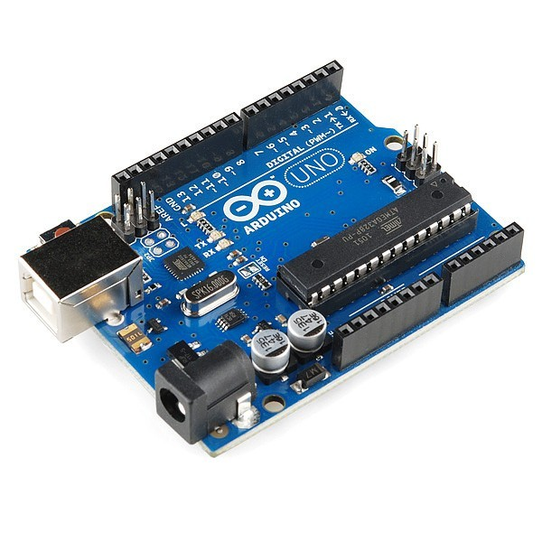

Fig.6. Arduino UNO Board

Arduino Uno is a microcontroller board which is based on the ATmeg328P(datasheet). Arduino is an open source platform which is used to build various projects.. It consists of a circuit board which is programmable. There are 14 digital input/output pins(out of which 6 can be used as PWM outputs),6 analog inputs,a USB connection, a 16MHz quartz crystal, a power jack, a reset button and an ICSP header in it. All that is needed to support the microcontroller is present in it. The only thing we need to do is to just connect it to the computer by powering it using an AC-to-DC adapter or battery, or just use a USB cable to get started. The adaptor can be connected by plugging 2.1mm centre-positive plug into a board’s power jack. Leads from a battery can be connected to the ground and the Vin pin headers of the power connector. This board operates on an external supply, from 6with an AC-to-DC adapter or battery to 20 V. When less than 7V is supplied, however the 5V pin supplies less than 5V and also the board may become unstable. Using more than 12V may overheat the voltage regulator and also damage the Arduino board. The range recommended is 7V to 12volts.

The power pins are as follows:-

* Vin- The voltage input to the Arduino board while it is making use of an external power source(as opposed to 5V from the USB connection or any other regulated power sources). The voltage can be supplied through the Vin pin or if supplying voltage the through power jack, it can be accessed through the Vin pin.
* 5V- This pin outputs a regulated 5V from the regulator on the board. The board can be supplied with power either from the DC power jack(7-12V), the USB connector(5V), or the Vin pin of the board(7-12V). Supplying voltage via the 5V or 3.3V pins bypasses the regulator, and can damage the board.
* 3V- A 3.3V supply is generated by the on-board regulator and the maximum current drawn is 50mA.
* GND- Ground points.
* IOREF- This pin on the arduino board provides the voltage reference with which the microcontroller operates. A properly configured shield can read the IOREF pin voltage and select the appropriate power source or enable voltage translators n the output to work with the 5V or 3.3V.

**POTENTIOMETER**

A potentiometer informally a pot is a 3 terminal resistor with a sliding contact that forms an adjustable voltage divider. When only two terminals are used,one end and the wiper, it acts as a rheostat or a variable resistor. A potentiometer measuring instrument is essentially a voltage divider used for measuring electric (voltage); the component is an implementation of the same principle, hence its name. Potentiometers are commonly used to control electrical devices such as volume controls on audio equipment. Potentiometers operated by a mechanism can be used as potential transducers, for example, in a joystick. Potentiometers are rarely used to directly control significant power (more than a watt), since the power dissipated in the potentiometer would be comparable to the power in the controlled load. As shown in the diagram a variable resistor consists of track which provides the resistance path. Two terminals of the device are connected to both the ends of the track. The motion of the wiper through the track helps in increasing and decreasing the resistance.

The track is usually made of a mixture of ceramic and metal or can be made of carbon as well. As a resistive material is needed, carbon film type variable resistors are mostly used. They find applications in radio receiver circuits, audio amplifier circuits and TV receivers. For applications of small resistances, the resistance track may just be coil of wire. The track can be in both the rotary as well as straight versions. In a rotary track some of them may include a switch. The switch will have an operating shaft which can be easily moved inthe axial direction with one of its moving from the body of the variable resistor switch. The rotary track resistor has two applications. One is to charge the resistance. The switch mechanism is used for the electric contact and non-contact by on/off operation of the switch. There are switch mechanism variable resistors with annular cross-section which are used for the control of equipment. Even more components are added onto this type of a variable resistor so as to make them compatible foe complicated electronic circuits. A high voltage variable resistor such as a focus pack is an example. This device is capable of producing a variable focus voltage as well as a screen voltage. It is also connected to a variable resistance circuit and also a fixed resistance circuit (bleeder resistor) to bring a change in the applied voltage. For this both the fixed and the variable resistor are connected in series. A track made in a straight path is called a slider. As a position of a slider cannot be seen or confirmed according to the adjustment of resistance, a stopping mechanism is usually included to prevent the hazards caused due to over rotation.

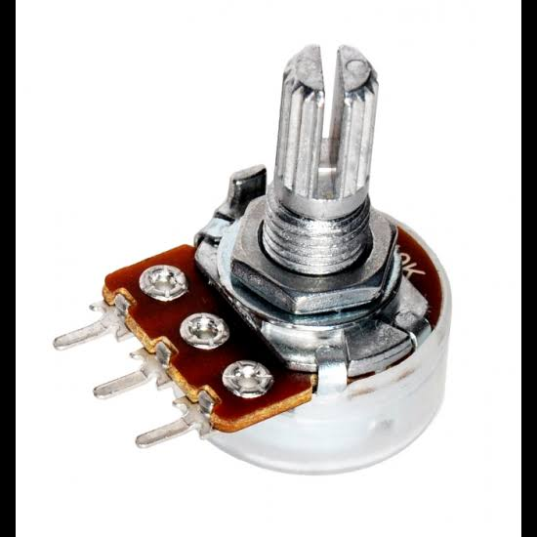

Fig.7. Potenti5ometer

**LED (Light Emitting Diode)**

The main specification of LED are its current rating = 20 mA, typical cut in voltage= 2 V, life time= 2 lakh hours, approx. voltage is around 4.5 V. There is different colour LED’s depending on the semi conducting material. LED has two leads – cathode and anode. They are identified by the length of the lead. Cathode lead is of lesser length. The maximum value of 470 ohm can be inserted for a small light.

LED is a semiconductor light source that emits light when current flows through it. When a current flow through the diode, electrons holes and electrons recombine with each other within the device which inturn releases energy as photos. This effect that occurs inside the LEDs is called Electroluminescence. Corresponding to the energy of the photons, the colour of the light is determined. This is determined by the energy band gap of the semiconductor. White light is obtained by using multiple semiconductors or a layer of light-emitting phosphor on the semiconductor device.

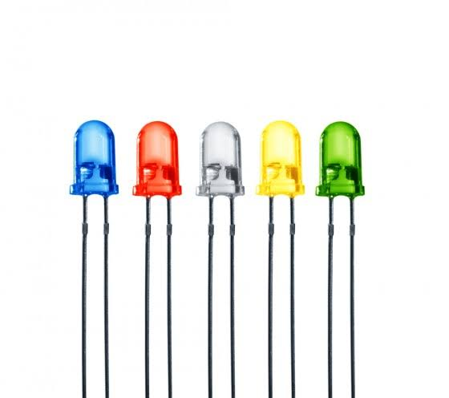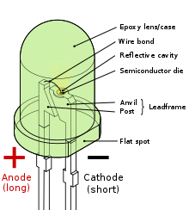

Fig.8. Light emitting diodes (LEDs) Fig.8.1. Parts of LED

**LCD DISPLAY**

An LCD [Liquid Crystal Display] is nothing but an electronic display module that utilises liquid crystal in order to produce an image that is visible. A very basic module used in circuits is the 16*2 LCD display. The 16*2 translates a display 16 characters per line in 2 such lines. Each character is displayed in a 5*7 pixel matrix in this LCD.

A 16*2 LCD consists of 2 registers, which is data and command. To change from one register to the other, the register select RS is used. That is, Register select=0 for command register and RS=1 for data register.

Command Register- The command instructions given into the LCD is stored by this register. Instruction given into LCD to do predefined tasks are called commands. The commands areprocessed by the command register.

Data Register- The data to be displayed on the LCD is stored by the data register. The ASCII value of the character to be displayed on the LCD is the data. The data sent to the LCD is processed by the data register.

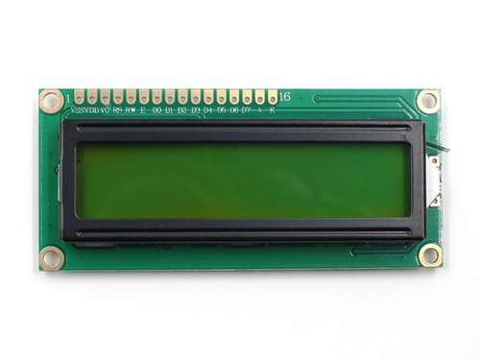

Fig.9.LCD Display

**BUZZER**

A buzzer is an efficient component which adds sound features to our project. It is a , electromechanical, mechanical, magnetic, electromagnetic, piezoelectric or electro-acoustic audio signalling device. It consists of an outside case with two pins to attach it to power and ground.

When current is applied to the buzzer it causes the ceramic disk to contract or expand. Changing this causes the surrounding disc to vibrate. By changing the frequency of the buzzer, the speed of the vibrations changes, which changes the pitch of the resulting sound.

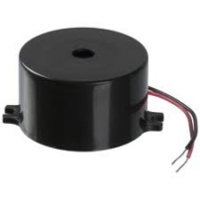

Fig.10.Buzzer

**CIRCUIT DIAGRAM**

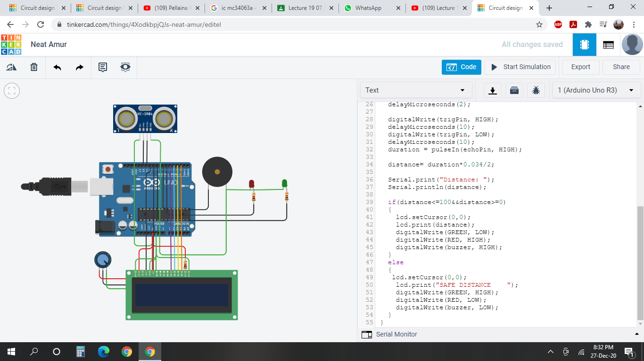

Fig.11. Circuit diagram of Covid Precaution Sensor

**CIRCUIT WORKING**

An Ultrasonic Sensor is used to measure the distance between the person and the obstacle. The trigger pin of the ultrasonic sensor is connected to pin 12 of the arduino, the echo pin is connected to pin 11, GND(ground pin) to the GND pin of arduino and the power pin is connected to 5V of arduino.The anode of red LED and green LED is connected to pin 6 and pin 8 of arduino respectively. The cathode of both the LEDs are connected to the GND pin of arduino.The negative terminal of the buzzer is connected to the GND pin of arduino. The positive terminal of buzzer is connected to pin 7 of arduino. DB7, DB6, DB5, DB4 pins of the LCD are connected to the pins 2,3,4,5 of the arduino. The enable pin and register pin of LCD are connected to pin 9 and pin 10 of the arduino respectively. The contrast of the LCD is connected to potentiometer wiper pin. The GND pin and LED cathode of LCD is connected to ground pin of arduino, the LED anode and power pin to the 5V power pin of arduino. The read/write pin is connected to GND pin of arduino.The terminal 1 of the potentiometer is connected to 5V of arduino and terminal 2 to GND pin of arduino.

The Ultrasonic Sensor measures the distance between the person and the obstacle. If the distance measured is less than or equal to 100cm the LCD will display the distance calculated and TAKE PRECAUTION, the red LED and the buzzer will turn on simultaneously. If the distance measured is greater than 100cm the LCD will display the distance calculated and SAFE DISTANCE, the green LED will glow in this case.

**HARDWARE PICTURE**

Fig.12. Hardware Picture

**RESULTS**

Although many precaution and safety measures such as face masks, hand sanitizers are taken by the government in order to reduce the spread of the disease the fact that the pandemic seemed weaker at some points, the safety regulations are still applied due to unstable situation.

The lack of approved vaccine and medication increases the threat of the spread of Covid-19.There are many innovations that have been created to combat and reduce the spread of the disease out of which social distancing has become a norm in any social event or public gathering.

Our project would help in ensuring social distancing at any social event or public gathering to help reduce the spread of the disease by using an ultrasonic sensor. This sensor measures the distance between itself and the object or person in front of it. If something is within the threshold distance (here 1m), the buzzer sounds, the red LED is turned on and the distance of the obstacle is displayed on the LCD along with a message TAKE PRECAUTION. If the distance is more than the set threshold value then the red LED will glow and the distance of the obstacle is displayed on the LCD along with a message SAFE DISTANCE.

**ADVANTAGES**

* Ensures social distancing.
* A warning is given if social distancing is not maintained.
* To prevent the spread of Covid-19.

**LIMITATIONS**

The device senses only the obstacles in front of the person and fails to detect any obstacle behind and beside the person.

**CONCLUSION**

Maintaining social distancing at social events and public gatherings will reduce the threat of the spread of Covid-19 to an extent and ensures individual safety. Social distancing plays a major role to help combat and reduce the spread of the deadly disease. Overall, as individuals, we have to start adapting social distancing as a precaution during the absence of an approved vaccine and medication. Therefore, our project ensures social distancing through its visual and audio aids via the buzzer LED and LCD.

Our project can be upgraded with the enforcement of technology by adding few features like temperature sensing which helps in detecting the body temperature of an individual and a mobile app connected to the device will help the guardian to ensure the safety of the child. We can make a 360 degree covid precaution sensor which will be more accurate in sensing obstacles around the person and not just in front of the person.

**APPENDICES**

|  |  |
| --- | --- |
| **ABSTRACT** | PAGE 4 |
| **ACKNOWLEDGEMENT** | PAGE 3 |
| **BIBLIOGRAPHY** | PAGE 25 |
| **BLOCK DIAGRAM** | PAGE 8 |
| **CIRCUIT DIAGRAM** | PAGE 17 |
| **CIRCUIT WORKING** | PAGE 18 |
| **CONCLUSION** | PAGE 22 |
| **HARDWARE PICTURE** | PAGE 19 |
| **HARDWARE REQUIREMENTS** | PAGE 10 |
| **LIST OF COMPONENTS** | PAGE 9 |
| **LIST OF FIGURES** | PAGE 24 |
| **INTRODUCTION** | PAGE 6 |
| **RESULTS** | PAGE20 |

**LIST OF FIGURES**

* Fig.1.1.Abstract
* Fig.1.2.Abstract
* Fig.2.1.Introduction
* Fig.2.2.Introduction
* Fig.2.3.Introduction
* Fig.3.Block Diagram
* Fig.4. Resistors
* Fig.4.1. Colour code of resistors
* Fig.5. Ultrasonic sensor
* Fig.5.1
* Fig.6.Arduino
* Fig.7. Potentiometer
* Fig.8.Light emitting diodes (LEDs)
* Fig.8.1.Parts of LED
* Fig.9.LCD
* Fig.10.Buzzer
* Fig.11.Circuit Diagram of Covid Precaution Sensor
* Fig.12.Hardware Picture

**BIBLIOGRAPHY**

* http://www.electronics-manufacturers.com
* www.tinkercad.com
* Timesofindia.indiatimes.com
* www.thenewsminute.com
* Principles of electronics by V.K. Mehta
* bangaloremirror.indiatimes.com
* economictimes.com